I. Points and Ordered pairs:
Points are plotted on a coordinate system (graph grid) called a Cartesian Plane.
Points are called Ordered Pairs because they have a specific order and they contain two coordinates:
x-coordinate and y-coordinate (x , y)

The Cartesian Plane or graph grid has two lines that divide it into four quadrants, the x-axis and the y-axis, and a beginning point called the origin.
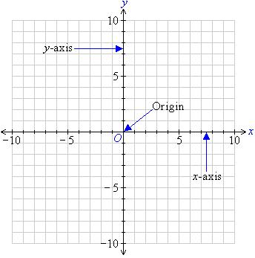

When plotting points (x , y), it’s the same as giving someone directions and your map is the graph grid.
The x-coordinate tells you where to move in the left-right direction from the origin.
The y-coordinate tells you where to move in the up-down direction from the origin.

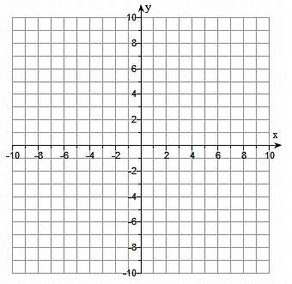
EXAMPLE:
Plot the following points on the graph grid:

A (1 , 2)

B (-3, 5)

C (4 , -4)

D (-5 , -7)

E (-8 , 0)

F (0 , 6)

G (7 , 8)

II. Linear equations are equations of lines. We see graphs of lines in business, sciences, math, computers, statistics, economics, and more.

The standard form of a linear equation is _________________________________________

In general, we graph lines by plotting points then connecting those dots to form a line. Sometimes points are lie on an axis. When points are on the x-axis or y-axis, then we call them ____________________. These are the points where a line crosses each axis.

A point on the x-axis is called the ______________________________________

A point on the y-axis is called the ______________________________________

To find the x-intercept, _________________________________________________________

To find the y-intercept, _________________________________________________________

EXAMPLES: Find the x-intercept and y-intercept for each linear equation. Plot the intercepts on the grid and connect the dots to form the line.

2x + 5y = 10 x-intercept:

y-intercept:

x – 3y = 6 x-intercept:

y-intercept:

x + y = 0 x-intercept:

y-intercept:

III. Vertical and Horizontal lines:

Vertical lines: ________________________________________________________________

___________________________________________________________________________

___________________________________________________________________________

EXAMPLES: graph the vertical lines x = 2 and x = -3

Horizontal lines: ______________________________________________________________

___________________________________________________________________________

___________________________________________________________________________

EXAMPLES: graph the horizontal lines y = -5 and y = 4

IV. Lines have slope. Slope measures the _______________________________________

Examples of things with slope: __________________________________________________

Slope is a fraction that measures:

Slope between two points on a line: (slope) m =

EXAMPLES: Find the slope of the line between each pair of points

(8, 1) (2, 6) (-2, -3) (-1, 5)

(3, 5) (-4, 5) (-3, 2) ( -3, -4)

V. Use the slope to help graph a line. All lines have a starting point. First, plot the starting point, then use the slope to find and make additions points. Remember slope is “rise over run”. Once you have two or more points, connect the dots to form the line.

EXAMPLES: graph the following lines using the given point and slope of the line

Point = (0, 1) Slope = $\frac{2}{3}$ Point = (-1, -2) Slope = $\frac{-3}{2}$

Point = (-5, 5) Slope = $\frac{4}{3}$ Point = (4, -8) Slope = 6

Point = (2, -5) Slope = 0 Point = (-7, -6) Slope = undefined

